2020 was one of the most stressful years most HR leaders have ever experienced, with tremendous pressure placed on us and our people teams as we confronted unimaginable crisis after crisis. While the challenges of charting a path forward amid a global pandemic, social unrest and inequity can be exciting, the toll this takes cannot be denied. As HR leaders, we focus on employee well-being, but how do we address burnout in ourselves and on our teams?
Join your peers at HR Strategy Forum’s second Community Conversation event Wednesday, April 21st from 12-1 PT. These Community Conversations are an opportunity to recharge, share ideas, deepen relationships, and gain new insights from a peer support network.
Our second session in 2021 is focused on HR burnout. As HR leaders, we focus on employee well-being, but how do we address burnout in ourselves and on our teams? Come explore how burnout is showing up in our teams, and what steps we can take to help re-energize our ourselves.

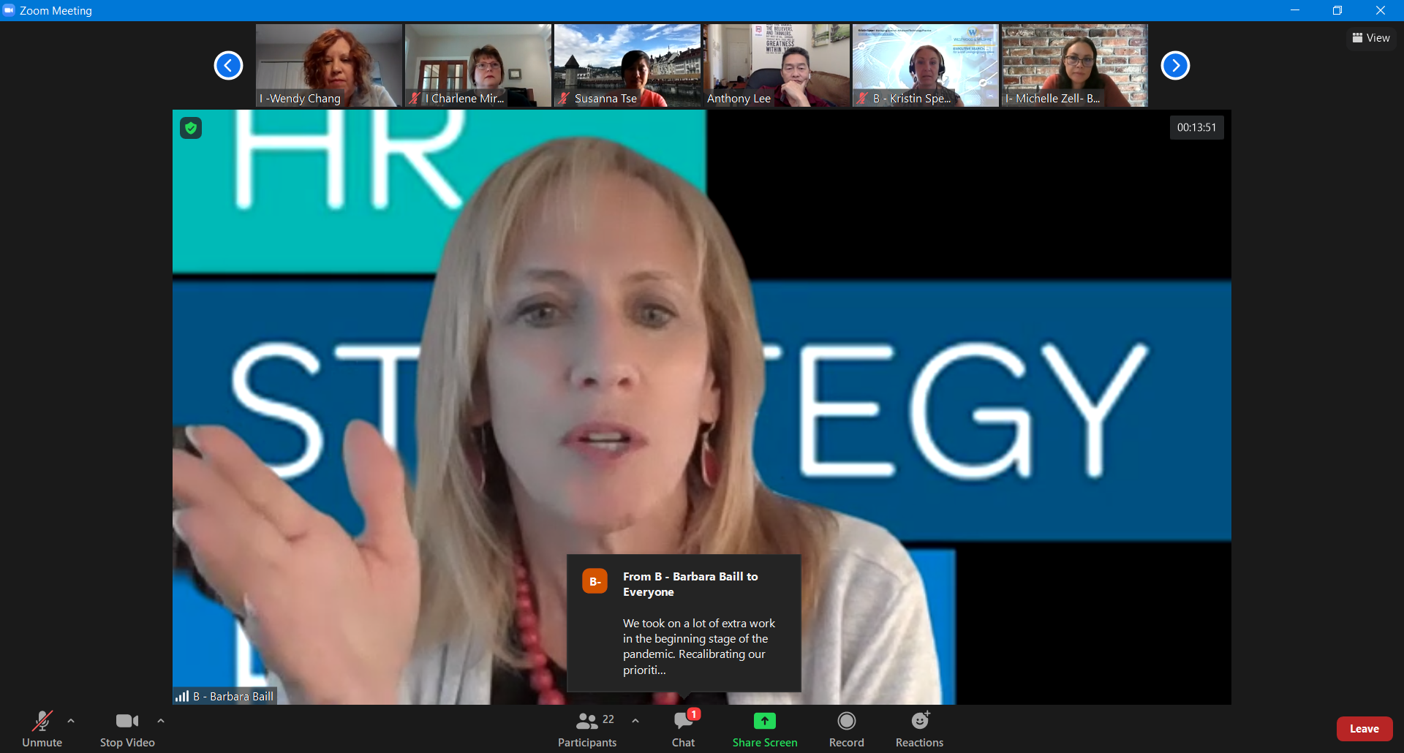
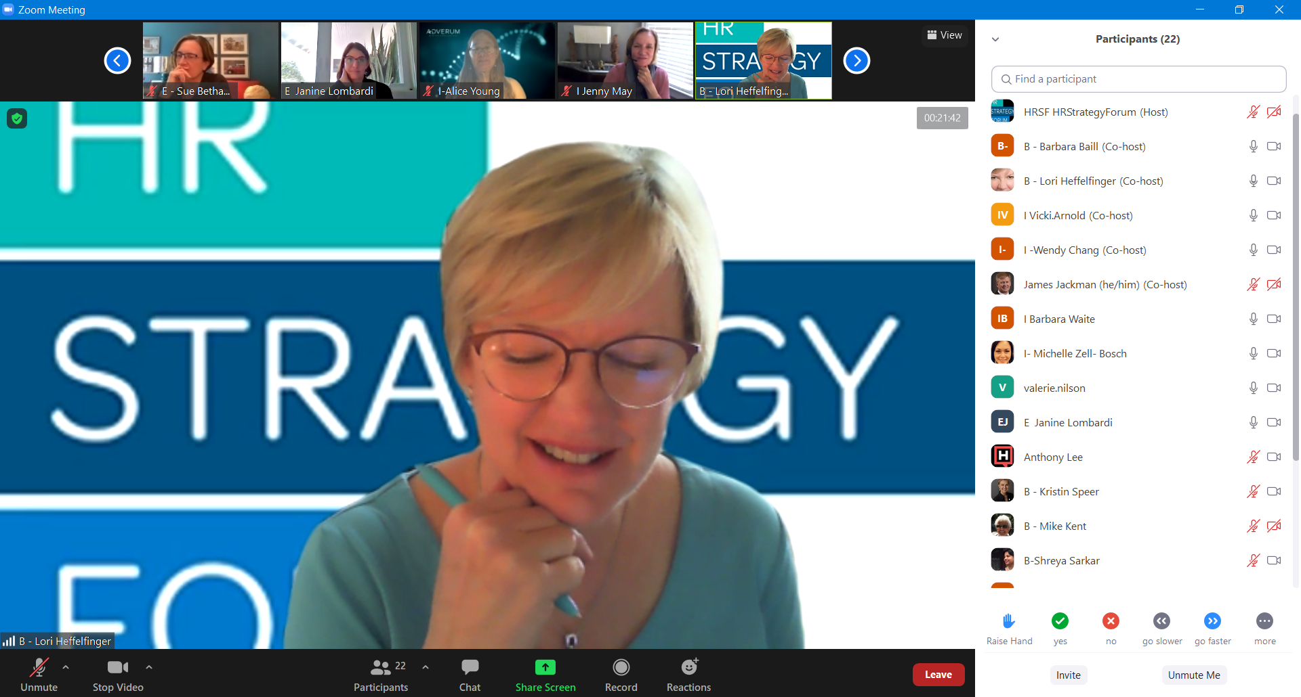
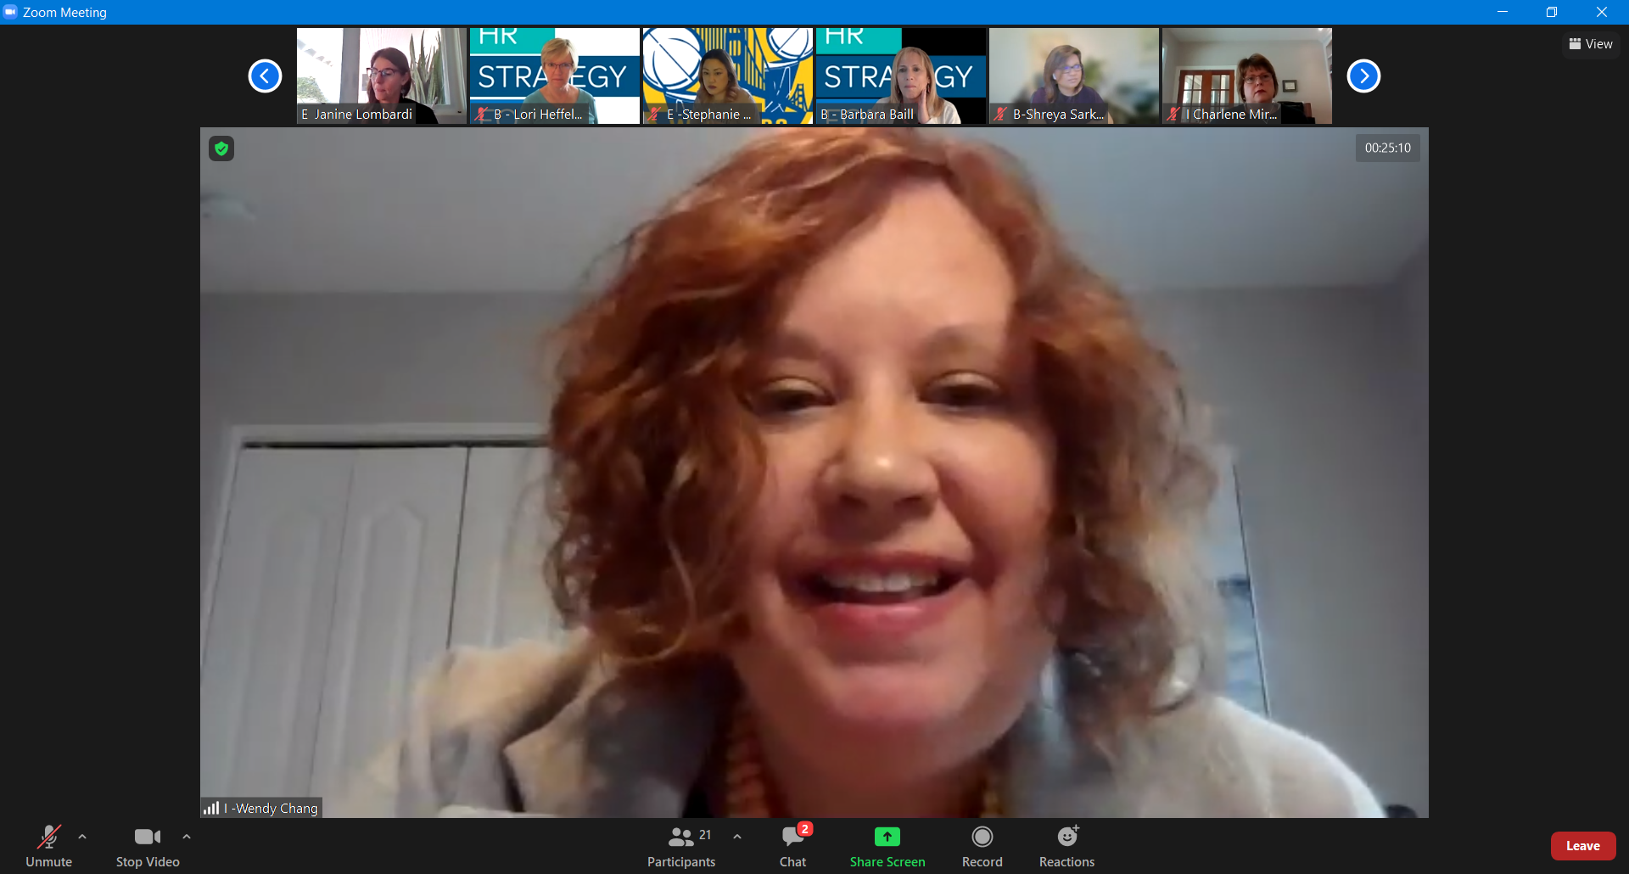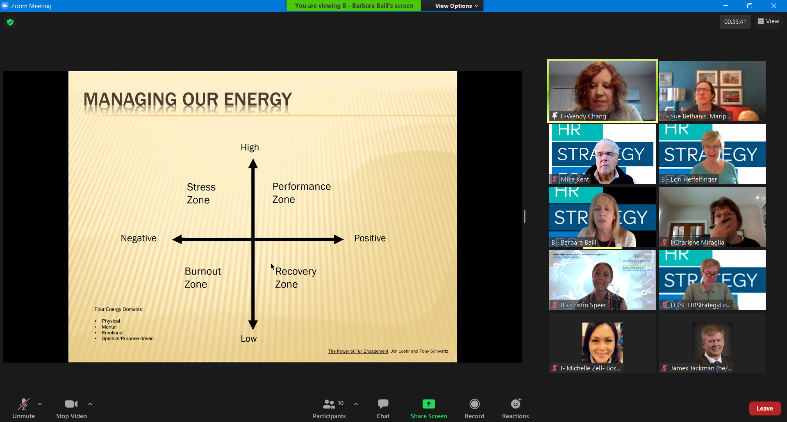

Chat Transcript from HRSF Community Conversation – HR Burnout, April 21, 2021

12:36:55 From E Janine Lombardi to Everyone : large group
12:38:28 From B - Barbara Baill to Everyone : What is the future of work
12:38:46 From B - Barbara Baill to Everyone : Global pace - addressing needs around the clock
12:39:01 From B - Barbara Baill to Everyone : Some groups are busy than other HR groups
12:39:13 From B - Barbara Baill to Everyone : The natural firefighters
12:39:49 From B - Barbara Baill to Everyone : General uncertainity
12:39:59 From B - Barbara Baill to Everyone : Personal interruptions
12:40:07 From B - Barbara Baill to Everyone : Vaccine policy?
12:40:27 From B - Barbara Baill to Everyone : Competing priorities within the business of HR
12:40:47 From B - Barbara Baill to Everyone : The computer at home is always there. No transition from work to home
12:41:51 From B - Barbara Baill to Everyone : Have to be strong and block out time for ourselves on the calendar
12:42:03 From B - Barbara Baill to Everyone : And stick to it
12:44:09 From B - Barbara Baill to Everyone : Every situation is unique now because of the pandemic
12:44:51 From B - Barbara Baill to Everyone : Responding the business up and downs
12:45:12 From B - Barbara Baill to Everyone : Forgetting that we are employees also
12:46:05 From B - Barbara Baill to Everyone : We took on a lot of extra work in the beginning stage of the pandemic. Recalibrating our priorities and focus is necessary
12:46:52 From B - Barbara Baill to Everyone : Wellness classes for the team
12:47:00 From B - Barbara Baill to Everyone : Meeting free Fridays
12:47:23 From B - Barbara Baill to Everyone : EAP Webinars for wellness
12:47:40 From B - Barbara Baill to Everyone : Team wellness challenges
12:48:35 From B - Barbara Baill to Everyone : Vacation time - actually taking it!
12:50:28 From B - Barbara Baill to Everyone : Bonus days off
12:50:36 From B - Barbara Baill to Everyone : Fridays off
12:51:17 From B - Barbara Baill to Everyone : Spring breaks
12:56:11 From B - Barbara Baill to Everyone : Fitness guru
12:56:17 From B - Barbara Baill to Everyone : Nutritionist
12:58:37 From I Vicki.Arnold to Everyone : Thanks for all the great ideas everyone! I do have to drop off at 1:00, Hope you enjoy the continued conversation.
13:00:56 From valerie.nilson to Everyone : Need to drop off. Thanks everyone!
13:00:59 From I-Alice Young to Everyone : Thank you all!
13:01:11 From Susanna Tse to Everyone : It was great to meet everyone! Thanks for sharing!
13:01:45 From E Janine Lombardi to Everyone : Appreciate the conversation today.
13:02:10 From I Barbara Waite to Everyone : will need to drop. thanks so much
13:02:10 From B - Kristin Speer to Everyone : Thank you, Barbara, Wendy, Lori, and the entire team that put today's discussion together.
13:02:23 From B-Shreya Sarkar to Everyone : Thank you, all. This was an insightful conversation.
13:07:14 From I- Michelle Zell- Bosch to Everyone : All of the Senior Leaders at our site read this book 2 years ago
13:09:45 From I- Michelle Zell- Bosch to Everyone : Need to drop off. Thank you everyone!
13:25:36 From B - Kristin Speer to Everyone : Great conversation, I have an interview starting soon, will hop off. Thanks, everyone!
13:25:49 From I Charlene Miraglia to Everyone : I have to run - thank you to everyone!!

