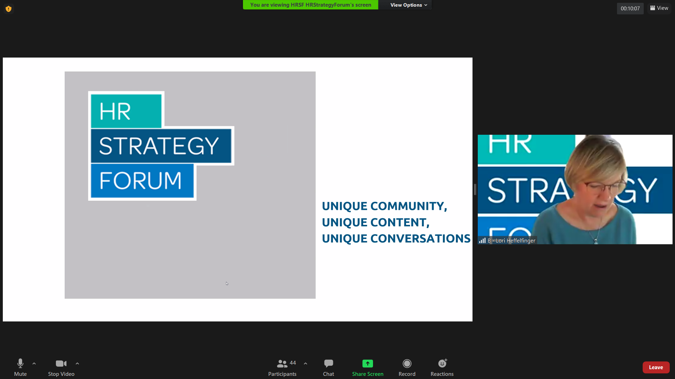

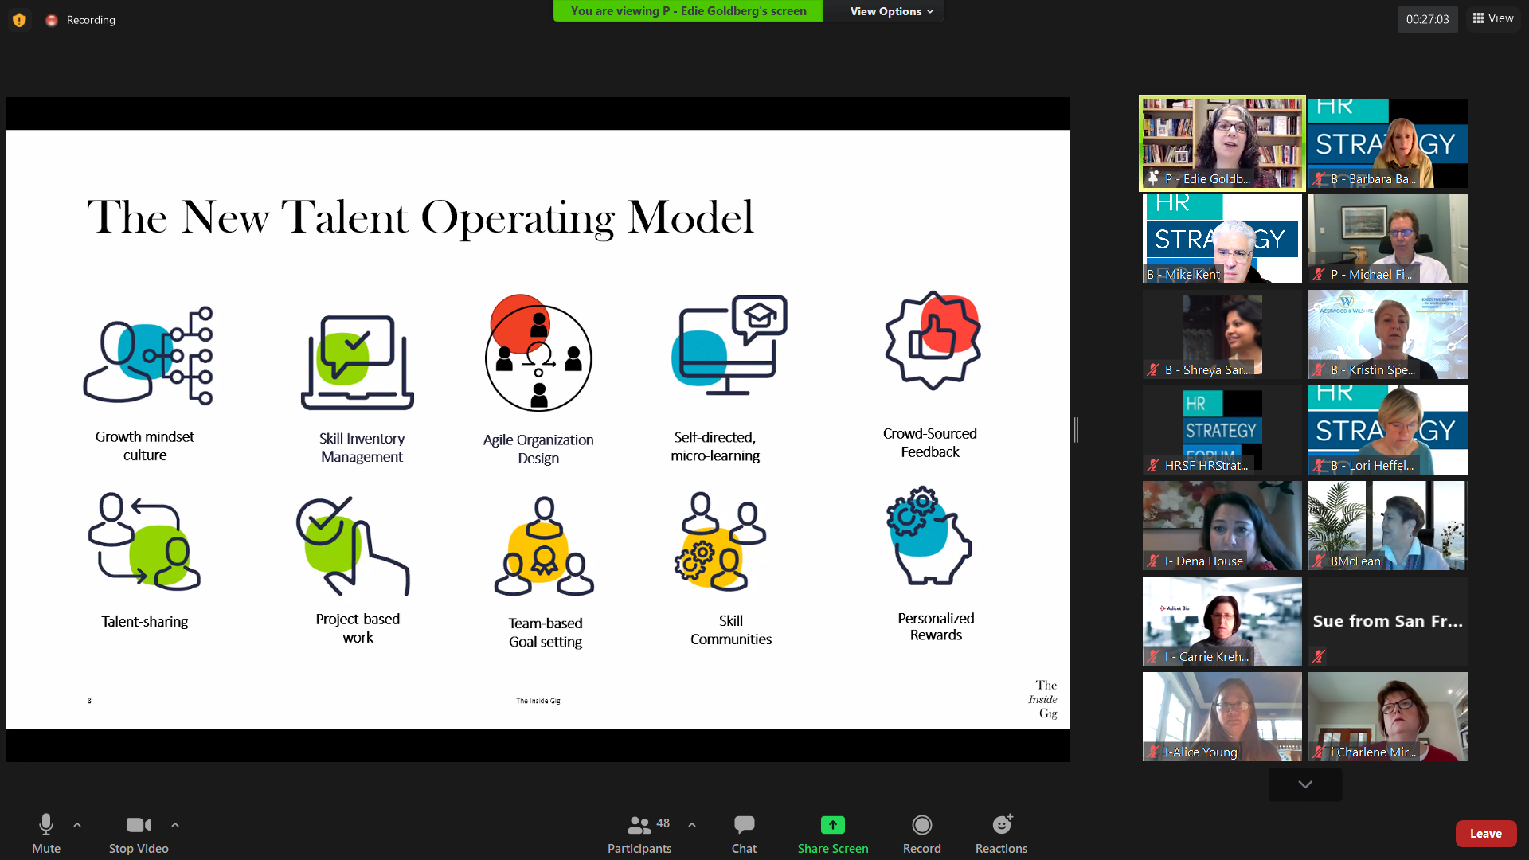
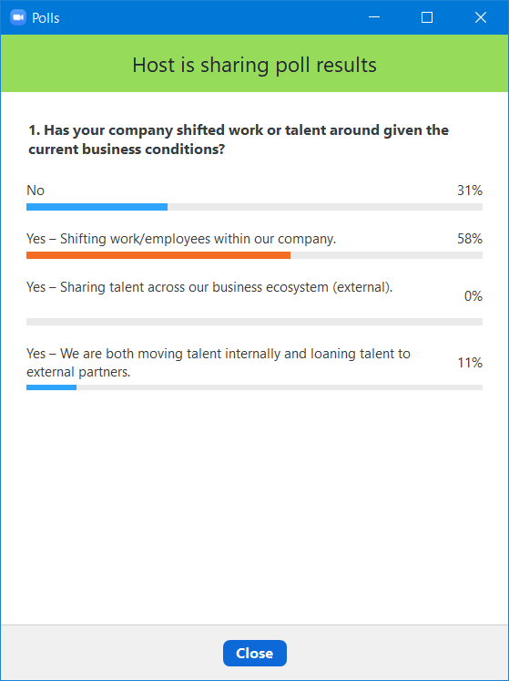
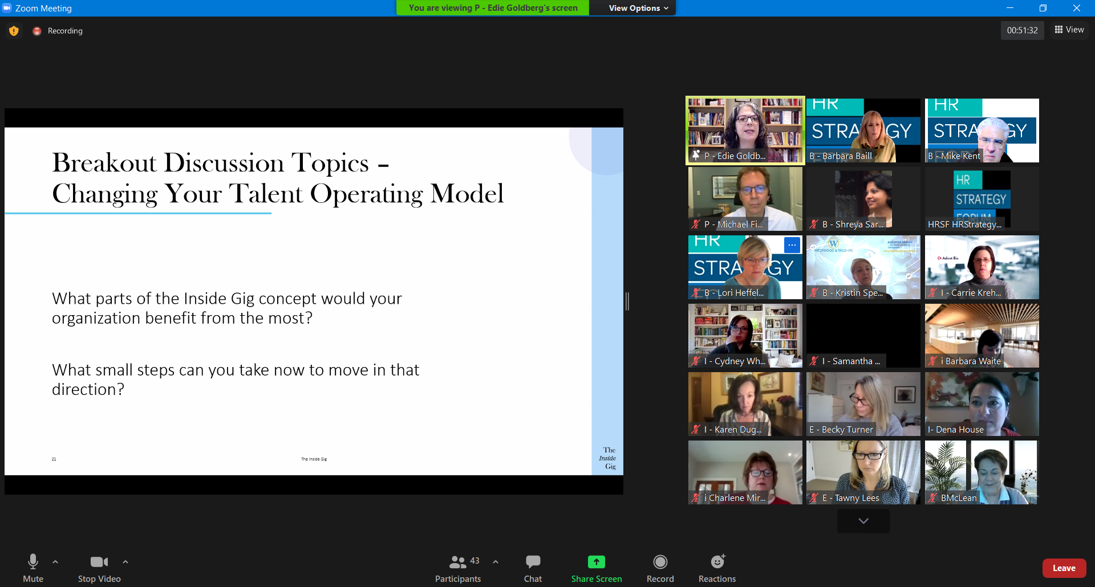
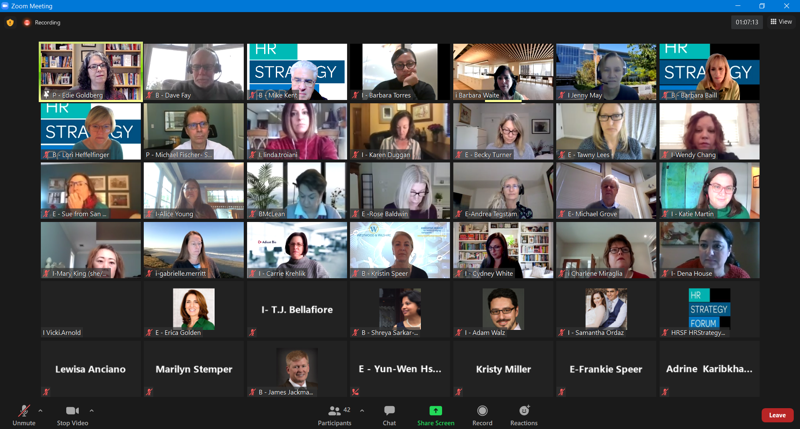
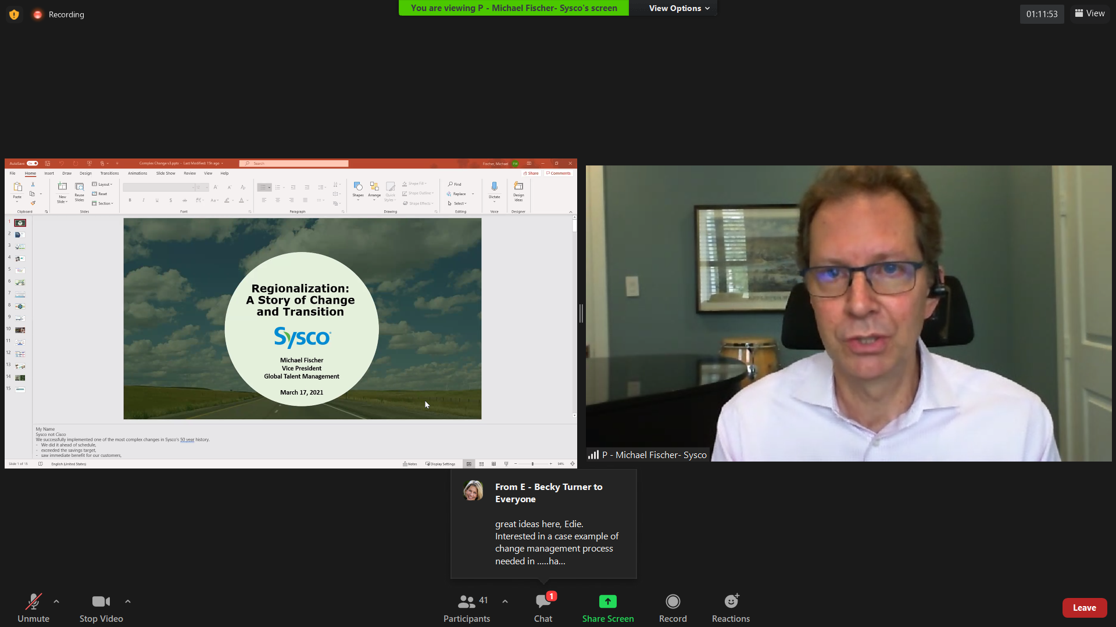
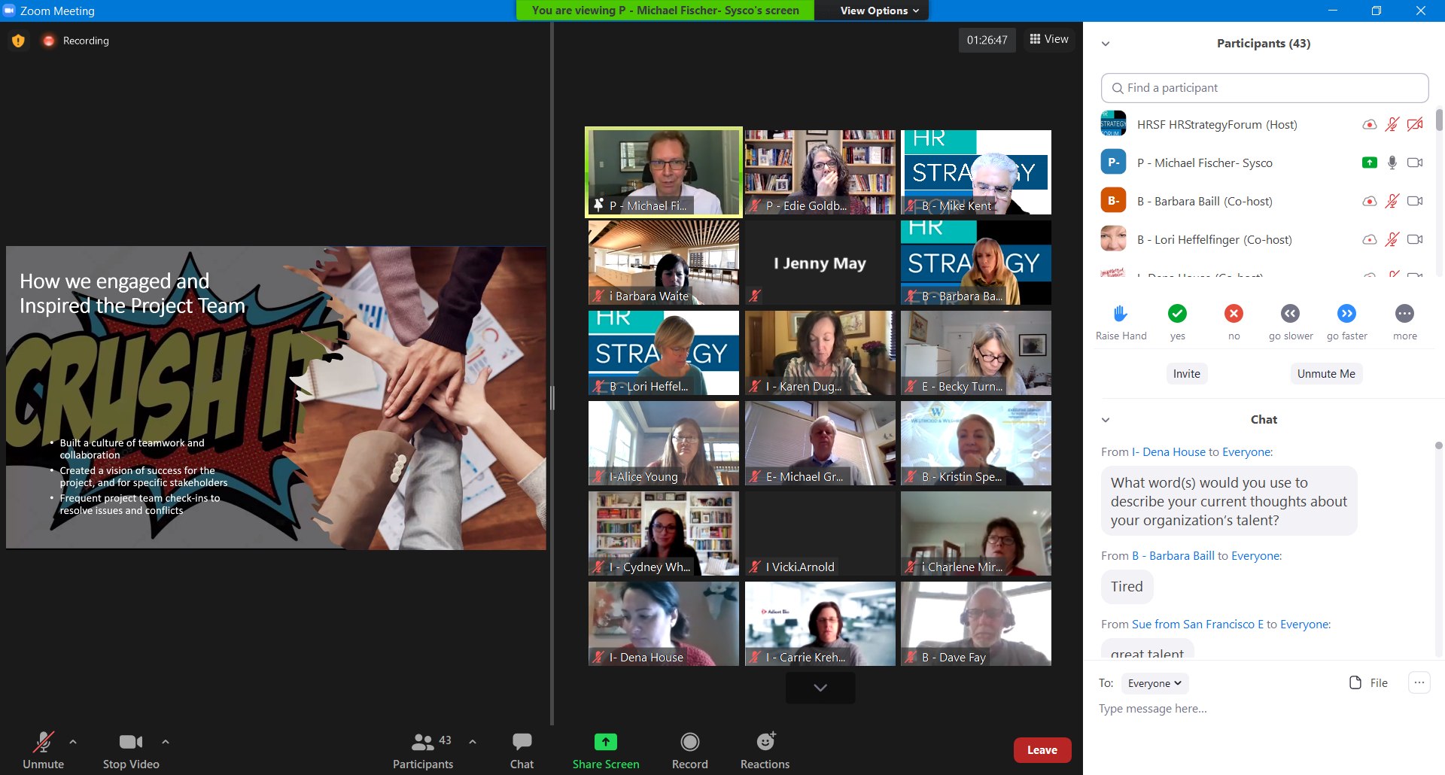
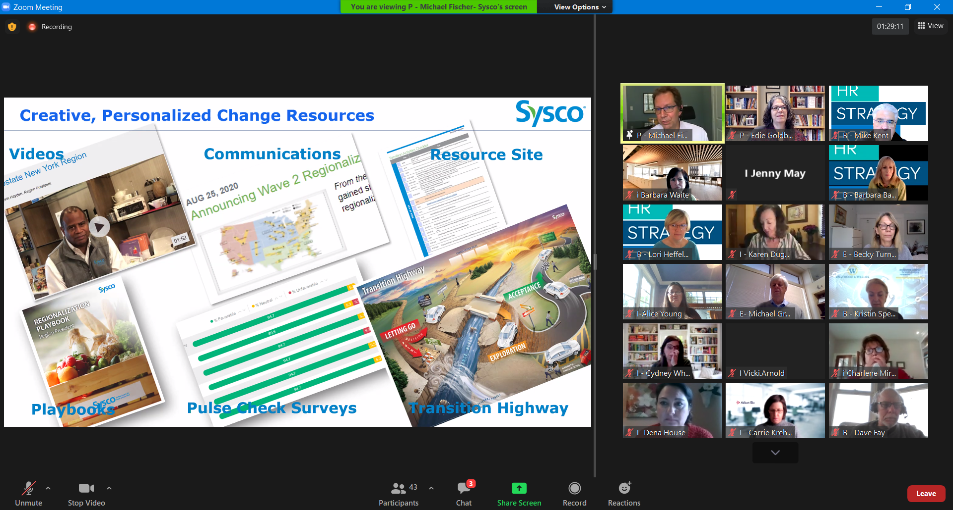
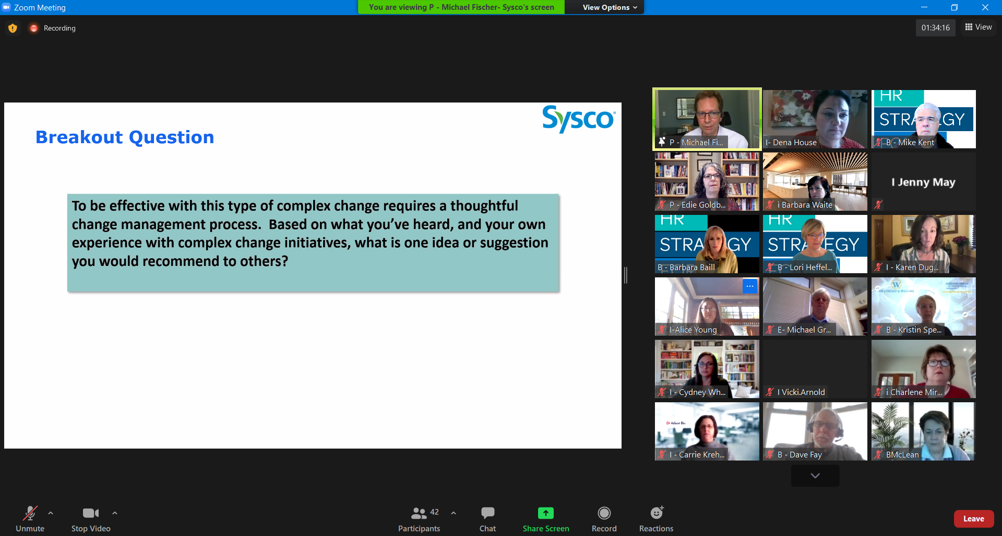

Chat Transcript from HRSF Program 3-17-21 A New Talent Operating Model

09:01:01 From I- Dena House to Everyone : What word(s) would you use to describe your current thoughts about your organization’s talent?
09:01:14 From B - Barbara Baill to Everyone : Tired
09:01:46 From Sue from San Francisco E to Everyone : great talent
09:02:44 From I-Wendy Chang to Everyone : stretched
09:02:47 From I - Carrie Krehlik to Everyone : highly motivated (to initiate our first in human study)
09:02:58 From I Vicki.Arnold to Everyone : Tired
09:03:01 From B - Kristin Speer to Everyone : Dedicated
09:03:37 From I - Karen Duggan to Everyone : Varied (fatigued, committed, uncertain)
09:03:37 From B - Dave Fay to Everyone : engaged
09:04:05 From Alice Young to Everyone : Flourishing
09:04:15 From Ashley Morris to Everyone : all over the place
09:04:50 From I- Dena House to Everyone : passionate
09:04:57 From I Jenny May to Everyone : Passionate
09:05:05 From gabrielle.merritt to Everyone : exhausted
09:05:06 From I - Cydney White to Everyone : eager
09:05:08 From linda.troiani to Everyone : intentional
09:05:11 From i Charlene Miraglia to Everyone : Varied - some very engaged and others very stressed/fatigued
09:05:41 From E - Becky Turner to Everyone : E Becky Turner
09:06:58 From E -Rose Baldwin to Everyone : Experts
09:11:16 From I- Dena House to Everyone : Introductions: Name, Company, Email, and Internal or External
09:11:36 From I- Dena House to Everyone : Rename yourself, place an “I” if internal or an “E” if external in front of your name.
09:13:08 From I- Dena House to Everyone : Please mute yourself during each speaker’s presentation and put your questions into chat.
09:13:44 From I - Carrie Krehlik to Everyone : Carrie Krehlik, CHRO at Adicet Bio, ckrehlik@adicetbio.com
09:14:42 From I - Samantha Ordaz to Everyone : Samantha Ordaz, Sr. HR Programs and Systems Manager at Adverum Bio, sordaz@adverum.com
09:14:53 From I- Dena House to Everyone : Dena House, Adverum Biotechnologies, dhouse@adverum.com, Internal R
09:15:29 From B - Dave Fay to Everyone : Dave Fay, transitioning HR leader at present, faydave@gmail.com
09:15:43 From E - Yun-Wen Hsueh to Everyone : Yun-Wen Hsueh, HR Generalist at Guittard Chocolate Company, yhsueh@guittard.com
09:15:44 From I - Katie Martin to Everyone : Katie Martin, CSAA Insurance Group, Katie.martin@csaa.com, Internal
09:15:58 From I - Cydney White to Everyone : Cydney White- VP People Services for A. H. Belo Corporation. Cydney.white@ahbelo.com
09:16:05 From i Charlene Miraglia to Everyone : Charlene Miraglia, Principal, Human Resources, CannonDesign, cmiraglia@cannondesign.com, Internal
09:16:11 From I Vicki.Arnold to Everyone : Vicki Arnold, VP Human Resources QSC LLC Interanl
09:16:16 From Sue from San Francisco E to Everyone : Sue Bethanis ceo Mariposa Leadership
09:16:42 From I - Barbara Torres to Everyone : Barbara Torres, HR/Labor Relations Manager @ Swinerton Builders barbara.torres@pepperdine.edu
09:16:50 From I-Mary King (she/her) to Everyone : Mary King, Sr. Director, HR, CSAA Insurance Group, Internal HR, mary.king@csaa.com
09:16:55 From Sue from San Francisco E to Everyone : sueb@mariposaleadership.com
09:16:56 From I-Wendy Chang to Everyone : Wendy Chang HR Consultant and Transitioning HR Leader wendy.d.chang@gmail.com
09:17:17 From I - Ashley Morris to Everyone : Ashley Morris, Senior Org Development Consultant (internal) at Cedars-Sinai; ashley.morris@cshs.org
09:17:18 From BMcLean to Everyone : Bev McLean, Director Career and Professional Development Services at Saint Mary's College of California bam12@stmarys-ca.edu
09:17:33 From B - Barbara Baill to Everyone : Barbara Baill, Executive Coach, Perceptus, Inc.
09;17;33 From B – Mike Kent to Everyone: HRSF Board Member, Independent Mediator, Executive Coach and HR Consultant in Oakland, mlkent12@gmail.com
09:18:15 From E - Erica Golden to Everyone : Erica Golden SPHR, VP, Torchiana, egolden@torchiana.com
09:18:24 From B - Shreya Sarkar-Barney to Everyone : Shreya Sarkar-Barney, CEO Human Capital Growth shreya@humancapitalgrowth.com
09:18:34 From I - Cliff Burnette to Everyone : Cliff Burnette, Rambus, SVP & CHRO, cburnette@rambus.com
09:19:05 From I - Adam Walz to Everyone : Adam Walz, Senior L&OD Consultant, Autodesk, adam.walz@autodesk.com
09:19:24 From I Jenny May to Everyone : Jenny May, Sr Director HR, Commercial Teams, OpenText mayj@opentext.com
09:20:24 From Adrine Karibkhanyan to Everyone : Adrine Karibkhanyan, HR Business Partner, Age of Learning, Inc.; adrine.karibkhanyan@aofl.com
09:20:44 From E -Rose Baldwin to Everyone : Rose Baldwin, VP Client Services, Torchiana, HR leader, talent strategist…rbaldwin@torchiana.com
09:25:15 From I - Romina Moore to Everyone : Romina Moore, Director HRBP, Adverum Biotechnologies, rmoore@adverum.com
09:27:03 From E - Tawny Lees to Everyone : Tawny Lees, COO and Exec Coach, Mariposa Leadership, tawny@mariposaleadership.com
09:27:26 From B - Barbara Baill to Everyone : If you have questions for Edie, please enter into Chat.
09:27:43 From I-Alice Young to Everyone : Alice Young, Adverum Biotechnologies, HR Business Operations, ayoung@adverum.com
09:30:47 From B - Lori Heffelfinger to Everyone : Lori Heffelfinger, The Heffelfinger Company Exec Coaching and Leadership Company. Lorih@heffelfingerco.com
09:36:08 From I. linda.troiani to Everyone : Linda Troiani, HR Director, Thermo Fisher Scientific. linda.troiani@thermofisher.com
09:38:51 From B - Barbara Baill to Everyone : If you have questions for Edie, please enter into Chat.
09:39:17 From I- T.J. Bellafiore to Everyone : T.J. Bellafiore, OD leader, Kaiser Permanente, t.j.bellafiore@kp.org
09:40:56 From i Barbara Waite to Everyone : Recommendations for how you operationalize this new talent operating model in a small company (300 EEs)
09:41:34 From B - Lori Heffelfinger to Everyone : Great question Barbara
09:41:39 From E- Michael Grove to Everyone : Michael Grove, Chief Organizer of HumanCentric Labs, HCLabs.org (Also Disrupthr Bay Area).
09:46:16 From BMcLean to Everyone : Edie, We have partnered with an organization called ParkerDewey which provides short-term projects for our students in a variety of areas--HR, Finance, Operations, Research, Strategy, Marketing, etc. Do you have a similar platform for employees to get involved in projects to expand their learning and give them an opportunity to assist another vertical? Also, who is implementing the "Go Pro Early" concept of enterprises hiring high school students and partnering with higher education to ensure that the skills they need are being developed within the coursework at a college?
09:46:47 From I- Dena House to Everyone : Instructions for breakout rooms:
• Intro yourself.
• Choose a spokesperson.
• Discussion questions:
• What parts of the Inside Gig concept would your organization benefit from the most?
• What small steps can you take now to move in that direction?
10:03:03 From B - Barbara Baill to Everyone : Mindset shift is the key to all change and so challenging!
10:03:22 From B - Lori Heffelfinger to Everyone : So true Barbara!
10:03:39 From I. linda.troiani to Everyone : and employees have different expectations today
10:03:50 From I. linda.troiani to Everyone : we have to progress in this space
10:04:15 From B - Dave Fay to Everyone : Leadership must embrace and support this change or it will be hard to do
10:04:28 From B - Barbara Baill to Everyone : How are you rewarding managers who do give?
10:04:57 From P - Michael Fischer- Sysco to Everyone : I agree with you Dave. Leadership support is a critical part of this change.
10:05:44 From B - Barbara Baill to Everyone : Michael will share a great case study of gaining and keeping leadership support for change. Keep posted...
10:07:21 From E - Becky Turner to Everyone : great ideas here, Edie. Interested in a case example of change management process needed in …..haha you just introduced Michael!
10:07:46 From I - Katie Martin to Everyone : Group 4 - our discussion was similar. How do we address the scarcity mindset and get leaders to think of opportunities for gigs/stretch assignments? And finding opportunities to let employees promote their skills that we may not "see" in their current job - starting informally when there isn't a system, or more meaningfully in technology. When people do take on gigs, really hitting home the development/growth opportunity from it.
10:08:43 From I-Wendy Chang to Everyone : Is anyone looking at their total rewards system in relation this new talent operating model in moving to skill based rewards?
10:09:26 From i Charlene Miraglia to Everyone : Wendy - great question - I am wondering about that also!
10:09:50 From B - Barbara Baill to Everyone : High performing managers who get the reputation for being great managers to work for BECAUSE they give their people opportunities to grow is key. These managers need to be recognized and spotlighted.
10:10:40 From B - Dave Fay to Everyone : Totally agree Barbara....and in my experience there are too few of those (my exp anyway)
10:12:01 From P - Edie Goldberg to Everyone : @Wendy we do address the need to change rewards to support this new TOM in the book. I think we are all on a journey and don't have the definitive answer, but it is more about frameworks and paying for building capabilities that are important to the company.
10:13:58 From B - Barbara Baill to Everyone : In my experience coaching with leaders, it is so important to have them (1) ask their employee where they are interested in growing and (2) help them find project opportunities to fit the desire.
10:15:02 From P - Edie Goldberg to Everyone : @Barbara - Creating a reward system that supports the new approach to work is critical to demonstrating the importance and showing leaderships commitment to operating in this way
10:17:58 From B - Barbara Baill to Everyone : Agree!
10:18:41 From P - Edie Goldberg to Everyone : Love it. They said 2 years, you did it in 4 months! We can change in amazing ways if the company views it as critical to productivity/efficiency.
10:19:46 From B - Mike Kent to Everyone : If going from 76 to 32 has such big advantages, is the next step to move to even fewer regions over time?
10:19:53 From P - Edie Goldberg to Everyone : Great exposure to the rest of the company!
10:23:15 From I - Cydney White to Everyone : Will the slides from today's sessions be shared with the group?
10:24:19 From I - Karen Duggan to Everyone : Was this project team considered the ‘core job’ for the team members during this time? Specifically, if there were competing meetings for individuals would they prioritize this project, or their home base / day job?
10:24:24 From B - Barbara Baill to Everyone : Yes! The slides and recording of the presentations will be posted on our website after the session (couple days later).
10:29:22 From I- Dena House to Everyone : Breakout Question: We’ve been talking about complex change. To be effective requires a thoughtful change management process. Based on what you’ve heard, and your own experience with complex change initiatives, what is one idea or suggestion you would recommend to others?
10:37:26 From E - Becky Turner to Everyone : i popped out twice. So FYI internet unstable here — in case it happens again.
10:54:41 From I- Dena House to Everyone : Membership information in Chat:
https://hrstrategyforum.org/Membership-Info
10:55:00 From B - Dave Fay to Everyone : Wonderful session - thanks Edie and Michael!
10:55:09 From I - Cydney White to Everyone : Michael and Edie - How have you seen compensation structures adjust with this new model?
10:55:28 From I- Dena House to Everyone : input survey:
https://insight.humancapitalgrowth.com/index.php/749799?lang=en
10:55:38 From P - Michael Fischer- Sysco to Everyone : I enjoyed our time together. thanks everyone!
10:55:42 From Michael Grove to Everyone : Excellent Event!
10:55:43 From Rose Baldwin to Everyone : More HRSF programs on managing change! Critical as we return to workplace over the next year. Thank you, this was excellent
10:55:46 From P - Edie Goldberg to Everyone : Cyndy - feel free to f/u with. I can share what companies have discussed
10:56:05 From P - Michael Fischer- Sysco to Everyone : Edie, let's do this again :)
10:56:30 From E - Sue from San Francisco E to Everyone : curious about how planning for change is happening regarding going back to the office. there was no planning when the pandemic happened, but now we have time.
10:57:52 From I Vicki.Arnold to Everyone : Great session everyone!

