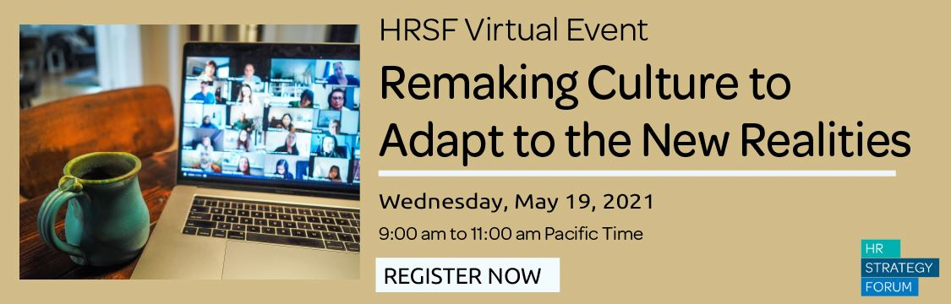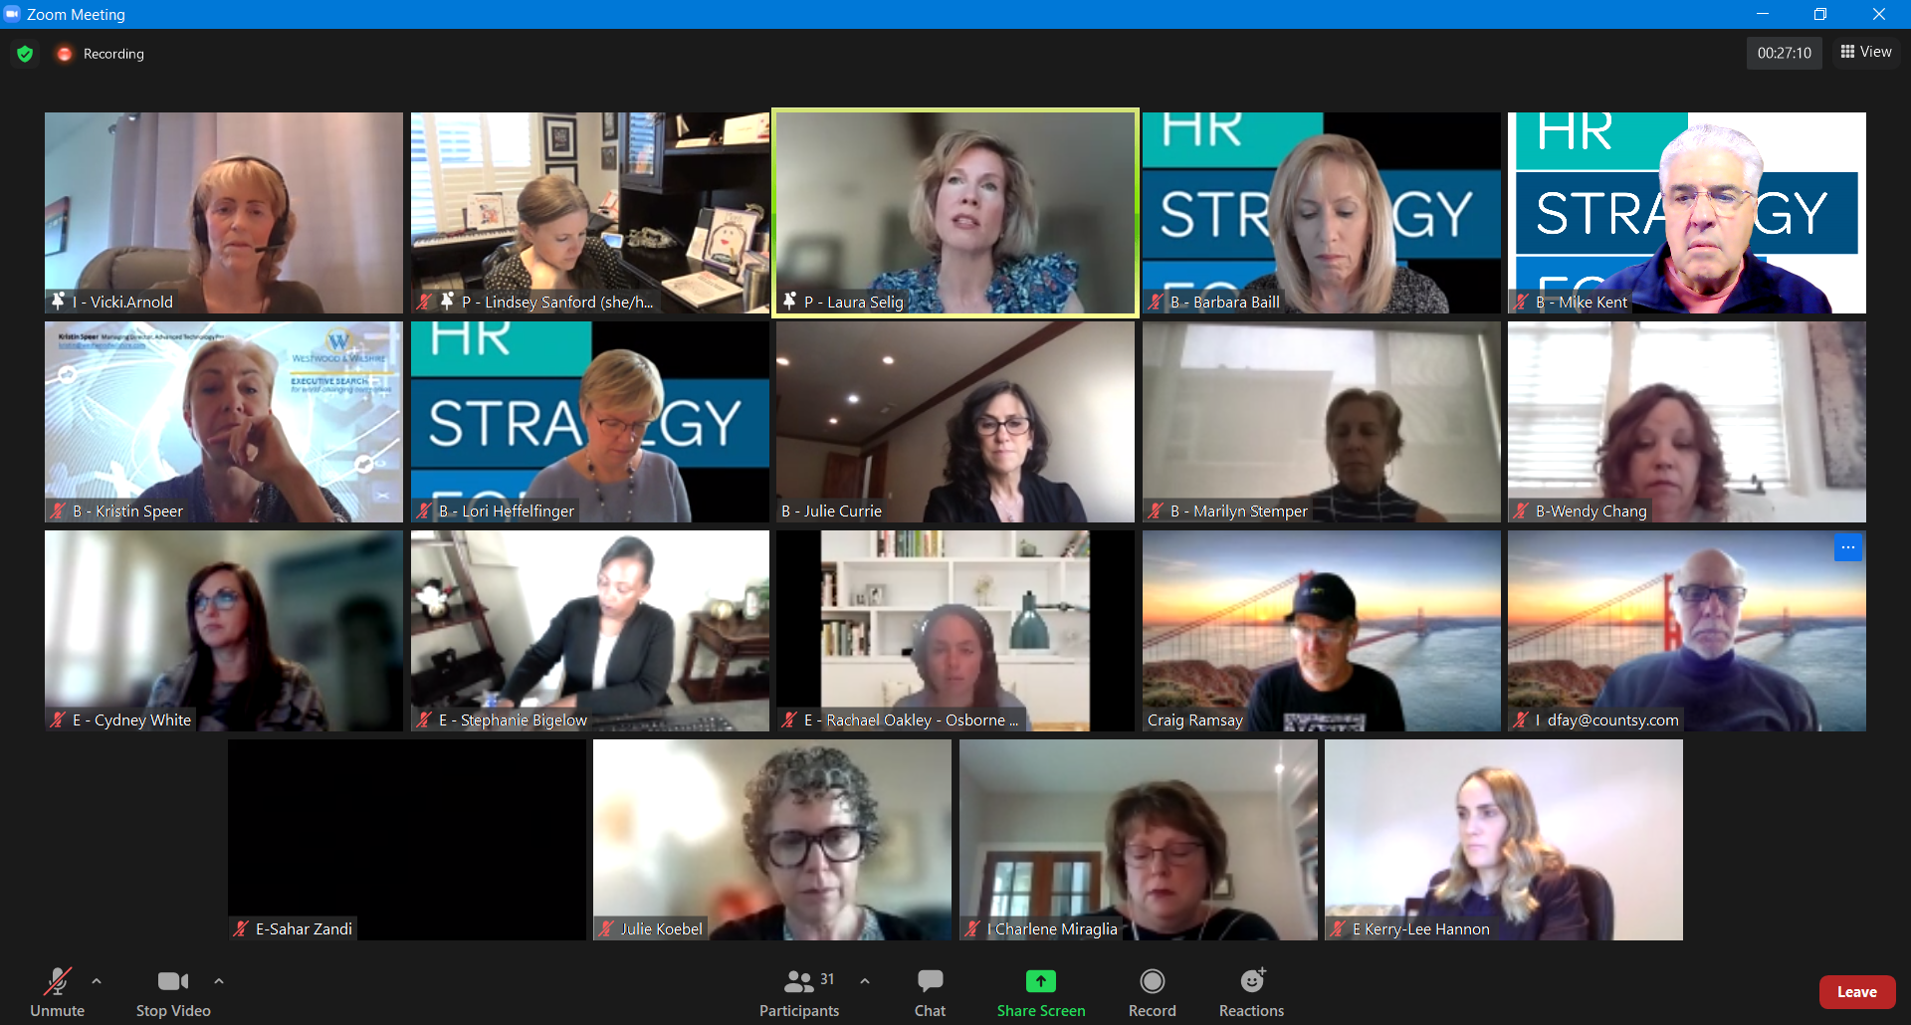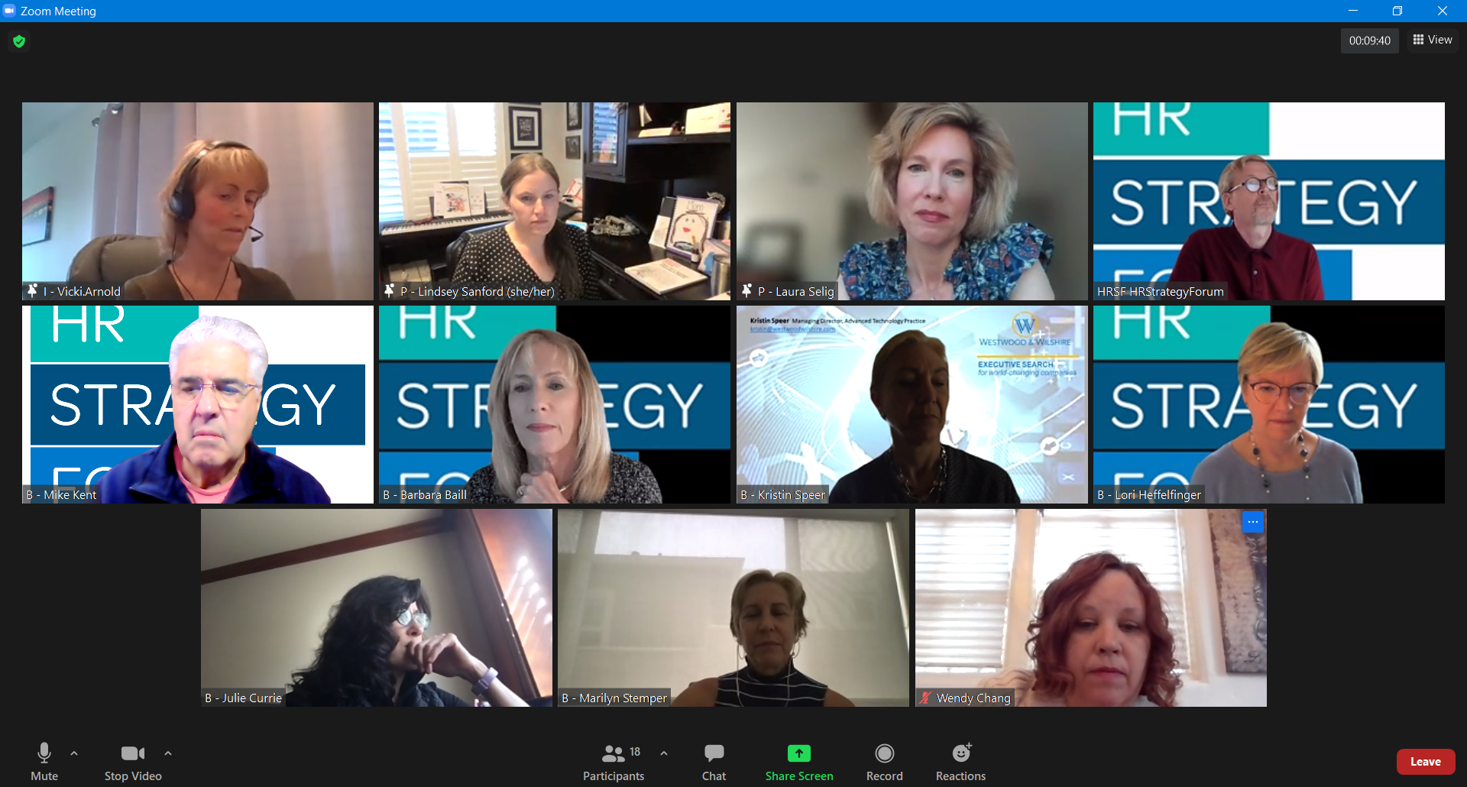
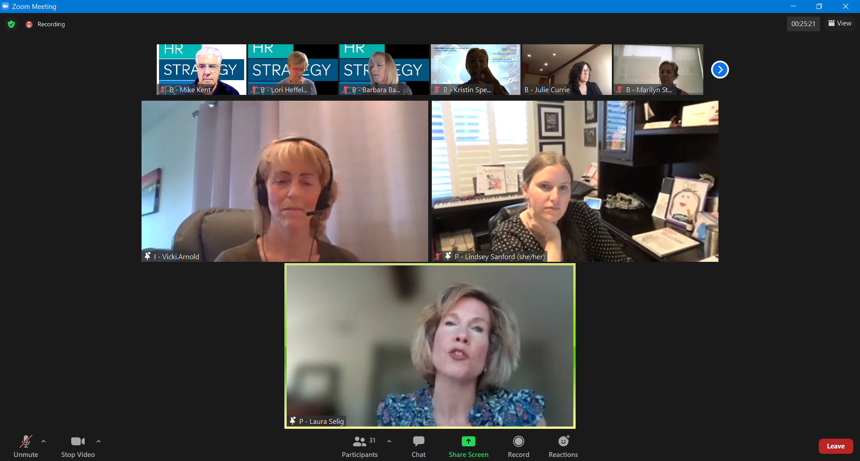
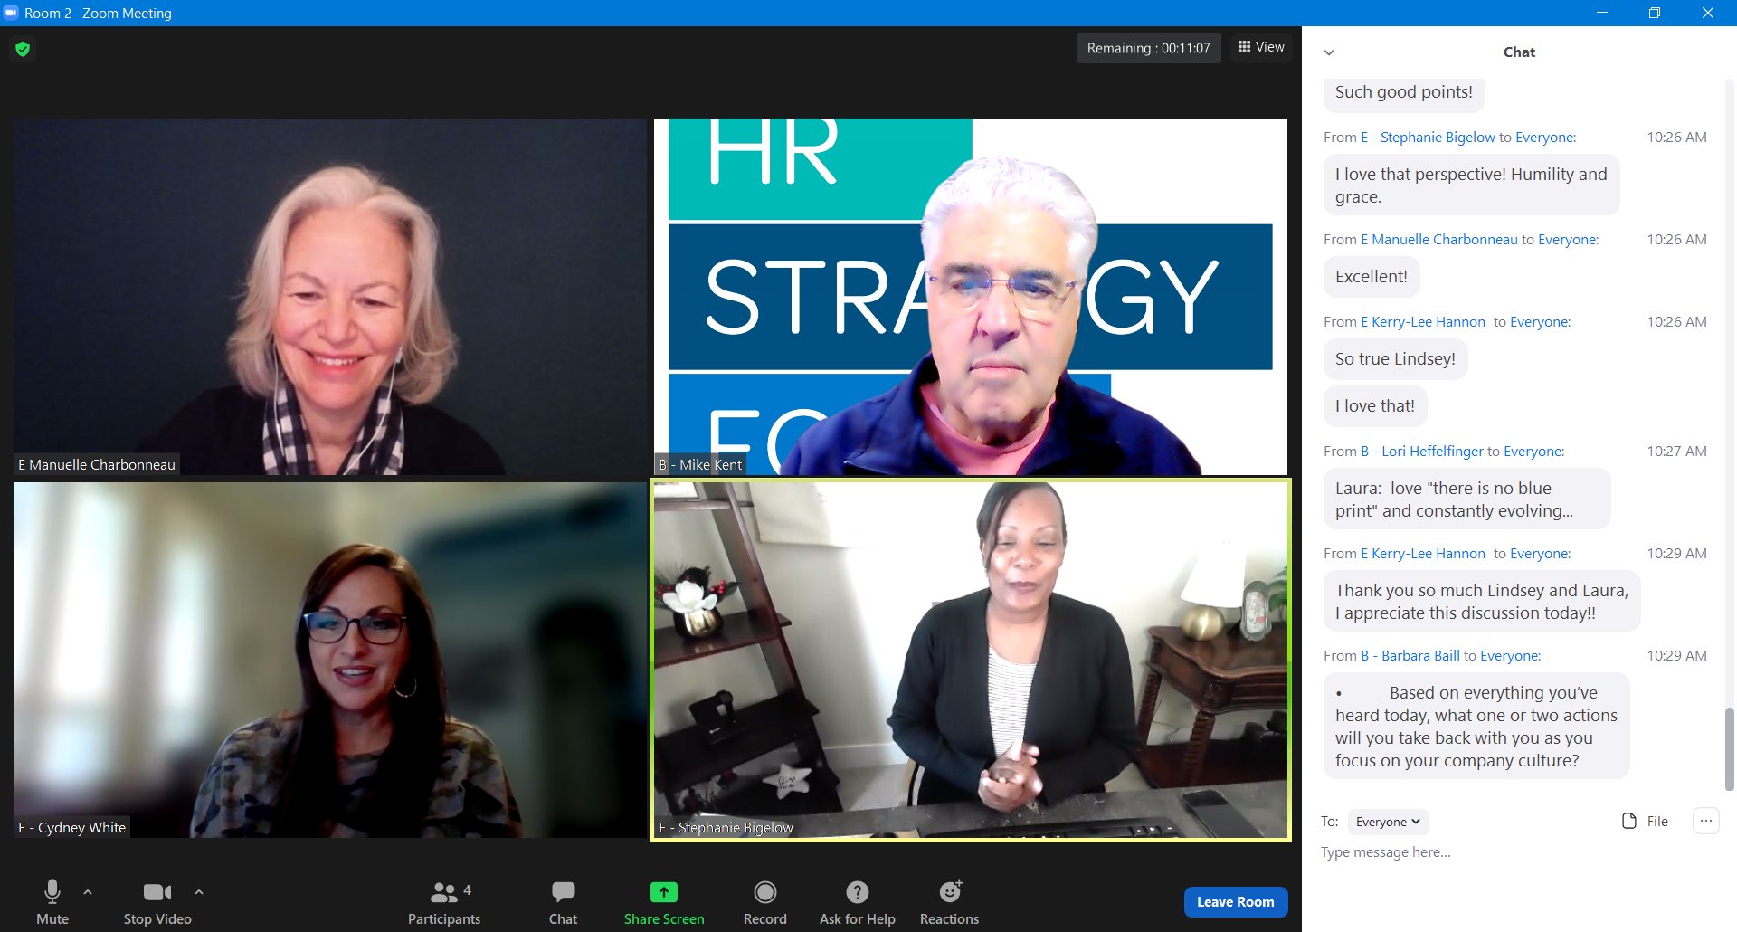

Chat Transcript from 5/19/21 HRSF Program

09:02:13 From B - Barbara Baill to Everyone : Welcome
09:02:55 From B - Barbara Baill to Everyone : Please Put an E for External and I for Internal in front of your name.
09:03:01 From E Kerry-Lee Hannon to Everyone : Good morning everyone :)
09:04:23 From B - Barbara Baill to Everyone : Please post your Name, Company, Email, and Internal or External
09:05:13 From I Charlene Miraglia to Everyone : Charlene CannonDesign, cmiraglia@cannondesign.com, Internal
09:05:13 From I dfay@countsy.com to Everyone : David Fay,Internal Countsy, dfay@countsy.com
09:05:13 From Craig Ramsay to Everyone : Craig Ramsay, Linkedin, cramsay@linkedin.com, internal
09:05:20 From E - Cydney White to Everyone : A. H. Belo Corporation cydneyewhite@gmail.com - External
09:05:23 From E - Stephanie Bigelow to Everyone : Kaiser Permanente, stephanie.a.bigelow@kp.org, external
09:05:44 From Sue Bethanis - E to Everyone : hi from Mariposa Leadership. sueb@mariposaleadership.com, external
09:05:48 From Jenny May to Everyone : Jenny may, OpenText, Senior Dir HR Commercial Teams, mayj@opentext.com
09:05:58 From Jerrica Villanueva - she/her to Everyone : Blend Labs, jer.gallardo@gmail.com, external
09:06:00 From E - Rachael Oakley - Osborne Clarke to Everyone : Hi!, rachael.oakley@osborneclarke.com, external
09:06:07 From B - Mike Kent : HRSF Board Member, Mediator, Executive Coach & HR Consultant mlkent12@gmail.com
09:06:39 From B - Julie Currie to Everyone : Good Morning, I’m Julie Currie CPO of Amplitude.
09:06:44 From E- Natalie Cook to Everyone : Natalie Cook, Backblaze, nataliec@backblaze.com, external
09:06:56 From B - Barbara Baill to Everyone : Barbara Baill, Executive Coach, Program Chair HRSF, Barbara@baill.com
09:07:10 From E - Amanda Rhodes to Everyone : Hi!, Regional HRBP at Carbon Health, ami.rhodes1@gmail.com
09:07:48 From B-Wendy Chang to Everyone : Wendy Chang, HR Consultant, wendy.d.chang@gmail.com
09:08:15 From I - Vicki.Arnold to Everyone : Vicki Arnold VP, HR QSC LLC vicki.arnold@qsc.com. Welcome everyone!
09:08:17 From E-Sahar Zandi to Everyone : Sahar Zandi, Clear Labs, sahar.zandi@clearlabs.com External
09:09:01 From E Kerry-Lee Hannon to Everyone : Senior HR Consultant. kezsa01@icloud.com. So nice to meet you all!
09:13:51 From B - Lori Heffelfinger to Everyone : President HRSF and The Heffelfinger Co. lorih@heffelfingerco.com
09:18:50 From Julie Koebel to Everyone :Julie Koebel Director, HRBP TriNet. Julie.koebel@trinet.com
09:18:57 From B - Marilyn Stemper to Everyone : National Director, Intoo Outplacement; Marilyn.stemper@intoo.com
09:23:14 From B - Barbara Baill: Please add your comments and questions in chat. Want to capture your thoughts!
09:27:39 From B - Mike Kent to Everyone : Welcome to our newest Sponsor, Merit Resource Group in Walnut Creek
09:36:06 From E - Julie Koebel to Everyone : My sense is there is a lot of fear of losing employees if 100% flexibility/ remote work is not offered. How do you "personalize" from a compliance perspective and address inevitable performance challenges? This is really for Lindsay - based on the approach she shared that Palo Alto Networks is taking
09:37:24 From David Gray to Everyone : PANEL: You all sound empathetic yet UNLIKE most RTO letters/announcements (especially financial sector); Question on forced flexibility, should employees brace for a "Your position in SF at $150k is not available but it is in Utah/WFA at $120k"
09:39:42 From E Tawny Lees to Everyone : Curious how you are planning to support managers as it seems that a lot of the "tricky" parts of this extreme flexibility will fall on them day to day.
09:40:26 From B - Barbara Baill: Great questions! Keep them coming. Will address these upon return from our breakout!
09:42:36 From B - Barbara Baill to Everyone : Breakout question: What is your biggest concern about maintaining or enhancing company culture as we move out of the pandemic and into a “new normal”?
09:47:29 From E Kerry-Lee Hannon to Everyone : I love that!
09:48:45 From E Manuelle Charbonneau to Everyone : I love Flexassist and Flexconnect concepts! Are these available for organizations to purchase?
09:49:54 From B - Barbara Baill to Everyone : • Breakout Question - What is your biggest concern about maintaining or enhancing company culture as we move out of the pandemic and into a “new normal”?
10:11:24 From B - Barbara Baill to Everyone : Please put your breakout thoughts into chat.
10:12:21 From David Gray to Everyone : well summarized Rose!
10:12:32 From E Sally Thornton to Everyone : Question for L&L: Since metrics (OKR/KPIs) are so important, any key learnings for how those are determined in HR roles where it’s been “fuzzy” in the past? (e.g. HRBP would be one…)
10:14:40 From David Gray to Everyone : (have mtg look fwd to recording thx all)
10:22:22 From E Sally Thornton to Everyone : Well said Lindsey!!!!
10:25:55 From I Alex Allan to Everyone : Such good points!
10:26:16 From E - Stephanie Bigelow to Everyone : I love that perspective! Humility and grace.
10:26:53 From E Manuelle Charbonneau to Everyone : Excellent!
10:26:56 From E Kerry-Lee Hannon to Everyone : So true Lindsey!
10:26:58 From E Kerry-Lee Hannon to Everyone : I love that!
10:27:07 From B - Lori Heffelfinger to Everyone : Laura: love "there is no blue print" and constantly evolving...
10:29:50 From E Kerry-Lee Hannon to Everyone : Thank you so much Lindsey and Laura, I appreciate this discussion!!
10:29:52 From B - Barbara Baill to Everyone : •Breakout Question - Based on everything you’ve heard today, what one or two actions will you take back with you as you focus on your company culture?
10:45:44 From B - Barbara Baill to Everyone : Please put your actions into chat.
10:46:20 From P - Laura Selig to Everyone : i'm dealing with some wifi issues so apologies if I go off video
10:46:32 From I Charlene Miraglia to Everyone : Focus more on personalizing the employee experience
10:47:05 From E Manuelle Charbonneau to Everyone : Coaching leaders to be intentional with the culture they want to create, as opposed to either going back to the “old way” or letting things just fall where they fall.
10:47:40 From E - Rachael Oakley - Osborne Clarke to Everyone : Flexibility is key, but flexibility will need pilots and employee pulsing to ensure consistency in the approach to flexibility across the business
10:47:47 From I Sahar Zandi to Everyone : We discussed the importance of leadership being aligned. We need to put an emphasis on maintaining consistency and equity within the org. Flexibility is required all around—and ensuring that our values/culture dictate our principles and thought processes.
10:49:37 From E Rose Baldwin to Everyone : Take advantage of learning from the pandemic; OKRs having a process and cadence for accountability and transparency across the org; team “offsites” to reengage (not on Zoom or the office)
10:50:46 From E - Stephanie Bigelow: Moving towards an 'employee-centric' environment. Creating a culture of personalization. Understanding that one size does not fit all. Doubling down on our communication and accessibility.
10:51:19 From I Sahar Zandi to Everyone : Can you please share the articles?
10:54:56 From B - Lori Heffelfinger to Everyone : Both Laura and Lindsey have agreed to continue this conversation on our Slack Channel. Please join us there to continue. hrstrategyforum or submit your email and I will personally invite you!
10:55:02 From P - Lindsey Sanford (she/her) to Everyone : https://www.mckinsey.com/business-functions/organization/our-insights/covid-19-and-the-employee-experience-how-leaders-can-seize-the-moment
10:55:06 From P - Lindsey Sanford (she/her) to Everyone : https://qrisnetwork.org/sites/default/files/materials/ SCARF%20A%20Brain-based%20Model%20for%20Collaborating%20with%20and%20Influencing%20Others.pdf
10:55:45 From I Charlene Miraglia to Everyone : This is great - thank you!
10:55:53 From E - Rachael Oakley - Osborne Clarke to Everyone : Thank you!
10:55:55 From E- Natalie Cook to Everyone : Thank you!
10:55:59 From B Craig Ramsay to Everyone : Thanks Laura and Lindsey!
10:56:13 From E - Stephanie Bigelow to Everyone : Great conversation! I learned so much from the discussions.
10:56:15 From I Alex Allan to Everyone : Th am you very much, great discussion
10:56:17 From B - Kristin Speer to Everyone : Fantastic discussion, thanks everyone!
10:56:20 From Lindsay Putzer to Everyone : Thank you very much, great takeaways and discussion!
10:56:23 From P - Lindsey Sanford (she/her) to Everyone : https://neuroleadership.com/your-brain-at-work/scarf-model-motivate-your-employees
10:56:24 From E Sue Bethanis to Everyone : mahalo to all
10:56:32 From P - Lindsey Sanford (she/her) to Everyone : Thank you for the opportunity
10:56:32 From I Sahar Zandi to Everyone : Thanks, everyone
10:56:37 From E Manuelle Charbonneau to Everyone : Wonderful program with wonderful panelists!
10:56:44 From P - Laura Selig to Everyone : thank you all!

